FIU 2017 Spring

ESI 6455

Advanced Engineering Project Management

Yezehao Huai (5965823)

E-mail:yhuai001@fiu.edu

Chapter 13 HW: P490 E6

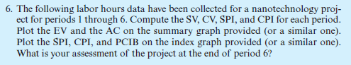

|  |  |  |  |  |  |  |  |  |  |  |  |  |  |  |  |  |  |  |  |  |  |
| --- | --- | --- | --- | --- | --- | --- | --- | --- | --- | --- | --- | --- | --- | --- | --- | --- | --- | --- | --- | --- | --- |
|  |  |  |  |  |  | 2 | 2 | 4 |  |  |  | 4 | 5 | 8 |  |  |  |  |  |  |  |
|  |  |  |  |  |  | 3 |  | 3 |  |  |  | 3 |  | 3 |  |  |  |  |  |  |  |
|  |  |  |  |  |  | 5 | 2 | 7 |  |  |  | 7 | 4 | 11 |  |  |  |  |  |  |  |
|  |  |  |  |  |  |  |  |  |  |  |  |  |  |  |  |  |  |  |  |  |  |
| 0 | 1 | 2 |  |  |  | 2 | 3 | 8 |  |  |  |  |  |  |  |  |  | 11 | 7 | 13 |  |
| 0 |  | 0 |  |  |  | 3 |  | 3 |  |  |  |  |  |  |  |  |  | 0 |  | 0 |  |
| 0 | 2 | 2 |  |  |  | 5 | 6 | 11 |  |  |  |  |  |  |  |  |  | 11 | 2 | 13 |  |
|  |  |  |  |  |  |  |  |  |  |  |  |  |  |  |  |  |  |  |  |  |  |
|  |  |  |  |  |  | 2 | 4 | 7 |  |  |  | 7 | 6 | 11 |  |  |  |  | LEGEND | | |
|  |  |  |  |  |  | 0 |  | 0 |  |  |  | 0 |  | 0 |  |  |  |  | ES | ID | EF |
|  |  |  |  |  |  | 2 | 5 | 7 |  |  |  | 7 | 4 | 11 |  |  |  |  | SL |  | SL |
|  |  |  |  |  |  |  |  |  |  |  |  |  |  |  |  |  |  |  | LS | DUR | LF |

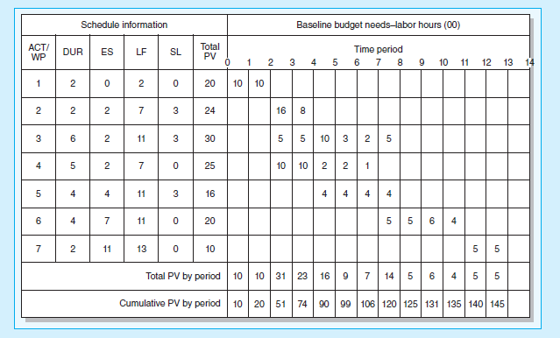

Status Report: Ending Period 1

|  |  |  |  |  |  |  |
| --- | --- | --- | --- | --- | --- | --- |
| **Task** | **Complete%** | EV | AC | PV | CV | SV |
| 1 | 50% | 1000 | 500 | 1000 | +500 | 0 |
| **Cumulative Totals** | | 1000 | **500** | **1000** | +500 | 0 |

Status Report: Ending Period 2

|  |  |  |  |  |  |  |
| --- | --- | --- | --- | --- | --- | --- |
| **Task** | **Complete%** | EV | AC | PV | CV | SV |
| 1 | Finished | 2000 | 1500 | 2000 | +500 | 0 |
| **Cumulative Totals** | | 2000 | **1500** | **2000** | +500 | 0 |

Status Report: Ending Period 3

|  |  |  |  |  |  |  |
| --- | --- | --- | --- | --- | --- | --- |
| **Task** | **Complete%** | EV | AC | PV | CV | SV |
| 1 | Finished | 2000 | 1500 | 2000 | +500 | 0 |
| 2 | 0% | 0 | 0 | 1600 | 0 | -1600 |
| 3 | 10% | 300 | 200 | 500 | +100 | -200 |
| 4 | 20% | 500 | 500 | 1000 | 0 | -500 |
| **Cumulative Totals** | | 2800 | **2200** | 5100 | +600 | -2300 |

Status Report: Ending Period 4

|  |  |  |  |  |  |  |
| --- | --- | --- | --- | --- | --- | --- |
| **Task** | **Complete%** | EV | AC | PV | CV | SV |
| 1 | Finished | 2000 | 1500 | 2000 | +500 | 0 |
| 2 | 50% | 1200 | 1000 | 2400 | +200 | -1200 |
| 3 | 30% | 900 | 800 | 1000 | +100 | -100 |
| 4 | 40% | 1000 | 1500 | 2000 | -500 | -1000 |
| **Cumulative Totals** | | 5100 | **4800** | 7400 | -300 | -2300 |

Status Report: Ending Period 5

|  |  |  |  |  |  |  |
| --- | --- | --- | --- | --- | --- | --- |
| **Task** | **Complete%** | EV | AC | PV | CV | SV |
| 1 | Finished | 2000 | 1500 | 2000 | +500 | 0 |
| 2 | Finished | 2400 | 2000 | 2400 | +400 | 0 |
| 3 | 50% | 1500 | 800 | 2000 | +700 | -500 |
| 4 | 60% | 1500 | 1500 | 2200 | 0 | -700 |
| 5 | 25% | 400 | 400 | 400 | 0 | 0 |
| **Cumulative Totals** | | 7800 | **6200** | 9000 | +1600 | -1200 |

Status Report: Ending Period 6

|  |  |  |  |  |  |  |
| --- | --- | --- | --- | --- | --- | --- |
| **Task** | **Complete%** | EV | AC | PV | CV | SV |
| 1 | Finished | 2000 | 1500 | 2000 | +500 | 0 |
| 2 | Finished | 2400 | 2000 | 2400 | +400 | 0 |
| 3 | 80% | 2400 | 2100 | 2300 | +300 | +100 |
| 4 | 80% | 2000 | 1800 | 2400 | +200 | -400 |
| 5 | 50% | 800 | 600 | 800 | +200 | 0 |
| **Cumulative Totals** | | 9600 | **8000** | 9900 | +1600 | -300 |

|  |  |  |  |  |
| --- | --- | --- | --- | --- |
| **Period** | **SPI** | **CPI** | **PCIB** |  |
| 1 | 1.00 | 2.00 | 0.07 |  |
| 2 | 1.00 | 1.33 | 0.14 | SPI=EV/PV |
| 3 | 0.55 | 1.27 | 0.19 | CPI=EV/AC |
| 4 | 0.69 | 1.06 | 0.35 | PCIB=EV/BAC |
| 5 | 0.87 | 1.26 | 0.54 |  |
| 6 | 0.96 | 1.20 | 0.66 |  |

From the above, after 6 time periods the project complete about 66%. The total work on the project has taken 1,600 hours less than planned. For the task 4 there are 400 hours work has not been finished. The CPI>1.0 means under cost and SPI<1.0 that shows it is behind schedule.